**M10D57PMPM – M8D30AM (diluted 1:1000)**

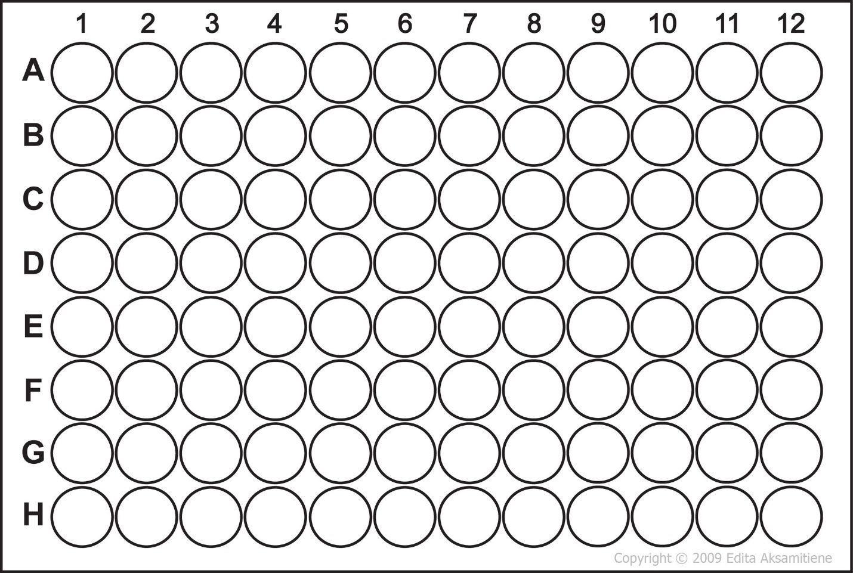

10d57pm

8d30am

7d30am

6d30am

4d30am

3d30am

5d39

4d39

2d39

3d36am

2d36pm

8d60pm

4d38

2d38

10d37pm

5d37pm

4d37pm

8d36pm

7d36pm

6d36pm

8d36am

10d60am

10d29pm

9d29pm

7d29pm

6d29pm

4d29pm

3d29pm

1d29pm

10d29am

9d29am

8d29am

7d29am

6d29am

5d29am

4d29am

3d29am

2d29am

1d29am

9d28pm

8d28pm

10d7

9d7

7d7

6d7

7d6

8d42am

8d39

2d30am

7d36am

7d62

10d62

3d35pm

4d35pm

7d35pm

8d35pm

9d35pm

10d35pm

2d36am

5d36am

6d36am

6d62

5d62

4d62

3d62

2d62

10d61

8d61

5d61

4d61

3d61

2d61

7d60pm

7d60am

5d60am

4d60am

3d60am

2d60am

7d59pm

5d59pm

4d59pm

2d59pm

10d59am

9d59am

8d59am

7d59am

3d59am

2d59am

8d58pm

5d58pm

3d58pm

7d58am

5d58am

3d58am

